Human Rights

Lesson Three: Economic, Social and Cultural Rights

Learning Objectives

Knowledge

1. Understand and clarify the key contents of some salient economic, social and cultural rights
2. Understand the importance of these economic, social and cultural rights
3. Realise the possible threats to these economic, social and cultural rights and suggest actions to protect them
4. Realise the interdependence of various human rights

Skill

1. Critical thinking skill

Values and Attitudes

1. Rational
2. Rules of Law
3. Fair and Justice

**3.1 Background of Economic, Social and Cultural right**

The Universal Declaration of Human Rights recognizes two sets of human rights: the “conventional” civil and political rights, as well as economic, social and cultural rights. Whilst economic, social and cultural rights have traditionally received much less attention as a group of universal human rights (no Hong Kong law, for example, explicitly acknowledges economic, social and cultural rights as human rights), their origins are in fact as deep-rooted in history as civil and political rights.

Almost all major religions in the world command that those in need and who cannot look after themselves be cared for. The teachings of Catholicism, for example, recognize the right to subsistence with dignity, as also does the Quran. Philosophers such as Karl Marx and John Rawls too have lent contemporary intellectual strength to the idea of economic, social and cultural rights.

It is at once obvious that the implementation of economic, social and cultural rights will have *financial implication* for the government. Nevertheless, as will be explained in the discussions that follow, the importance of economic, social and cultural rights means that the government must strike a fair balance between, on the one hand, promoting individual well-being and preserving the wider societal economic welfare on the other.

In this lesson, the following rights will be discussed:

* Rights to work and just and fair working conditions
* Right to social security
* Right to highest attainable standard of health
* Right to education
* Right to housing
* Right to culture

**3.2 Rights to work and to just and fair working conditions**

*(Art 23 UDHR; Art 6-7 ICESCR; Art 36 BL)*

|  |  |
| --- | --- |
| Art 23 UDHR | (1) Everyone has the right to work, to free choice of employment, to just and favourable conditions of work and to protection against unemployment.  (2) Everyone, without any discrimination, has the right to equal pay for equal work.  (3) Everyone who works has the right to just and favourable remuneration ensuring for himself and his family an existence worthy of human dignity, and supplemented, if necessary, by other means of social protection.  (4) Everyone has the right to form and to join trade unions for the protection of his interests. |
| Art 6 ICESCR | 1. The States Parties to the present Covenant recognize the right to work, which includes the right of everyone to the opportunity to gain his living by work which he freely chooses or accepts, and will take appropriate steps to safeguard this right.  2. The steps to be taken by a State Party to the present Covenant to achieve the full realization of this right shall include technical and vocational guidance and training programmes, policies and techniques to achieve steady economic, social and cultural development and full and productive employment under conditions safeguarding fundamental political and economic freedoms to the individual. |
| Art 7 ICESCR | The States Parties to the present Covenant recognize the right of everyone to the enjoyment of just and favourable conditions of work which ensure, in particular:  (a) Remuneration which provides all workers, as a minimum, with:  (i) Fair wages and equal remuneration for work of equal value without distinction of any kind, in particular women being guaranteed conditions of work not inferior to those enjoyed by men, with equal pay for equal work;  (ii) A decent living for themselves and their families in accordance with the provisions of the present Covenant;  (b) Safe and healthy working conditions;  (c) Equal opportunity for everyone to be promoted in his employment to an appropriate higher level, subject to no considerations other than those of seniority and competence;  (d ) Rest, leisure and reasonable limitation of working hours and periodic holidays with pay, as well as remuneration for public holidays |
| Art 36 Basic Law | Hong Kong residents shall have the right to social welfare in accordance with law. The welfare benefits and retirement security of the labour force shall be protected by law. |

The right to work is inseparably linked to an individual’s human dignity. This is because work contributes to the survival (through the income generated from work) of the individual and the family he or she has to support, the sense of self-fulfilment and recognition of that individual in the wider community.

To have the right to work means that work should be available, accessible and acceptable in quality.

1. Availability

The government has the obligation to assist and support individuals in identifying and finding available employment of their choice. "Free choice of employment" in this context does not mean that an individual has the right to do the exact job that he or she desires; rather, it guarantees each worker the genuine opportunity to be employed in a manner that is suitable to his or her skills.

The range of opportunities available to individuals will obviously be limited by the status of a country's social and economic development. The point is the government cannot just leave the status quo as it is.

1. Accessibility

This means that the labour market must be open to everyone without discrimination. The right of “access to employment” also implies that the government must work towards the ultimate objective of reaching full employment for every individual seeking to be employed.

The achievement of full access to employment is once again not an absolute requirement, but depends on multiple factors: the nation's economic climate, the nation's social policies, external constraints relating to international trade, availability of raw materials, etc.

1. Acceptability and quality.

Beyond the right to work, there are also a conglomerate of rights *at* work: everyone has a right to just and favourable conditions of work. They include a “remuneration that provides all workers with a decent living for themselves and their families”, “safe and healthy working conditions”, “equal opportunity for everyone to be promoted” and “rest, leisure and reasonable limitation of working hours and periodic holidays with pay, as well as remuneration for public holidays.”

Eg minimum wage, standard working hours

As a general principle, these are the minimum basic entitlements in keeping with human dignity, ie they are the “floor” under which employers and the government can no longer pretend that they respect the human dignity of the workers.

For example, “remuneration that provides a decent living” means that it must be sufficient so as to allow the worker and his or her family to enjoy all other economic, social and cultural rights, such as food, health care and education, based on objective factors such as the costs of living and other economic and social conditions. “Rest, leisure and reasonable limitation of working hours”, likewise, should serve to enable workers to recover from the fatigue of work and thereby lower the risks of health impairment which could result from accumulation of periods of work without the necessary rest.

Such basic entitlements should be recognized by the government in binding legislation as absolute minimum standards that are generally applicable to all workers, and cannot be derogated from even with the purported consent of the worker.

**

See further Committee on Economic, Social and Cultural Rights, *General Comment No 18* (2006) and *General Comment No 23* (2016).

**3.3** Right to social security

*(Art 22 UDHR; Art 9 ICESCR, Arts 36 and 145 BL)*

|  |  |
| --- | --- |
| Art 22 UDHR | Everyone, as a member of society, has the right to social security and is entitled to realization, through national effort and international co-operation and in accordance with the organization and resources of each State, of the economic, social and cultural rights indispensable for his dignity and the free development of his personality. |
| Art 9 ICESCR | The States Parties to the present Covenant recognize the right of everyone to social security, including social insurance. |
| Art 36 Basic Law | Hong Kong residents shall have the right to social welfare in accordance with law. The welfare benefits and retirement security of the labour force shall be protected by law. |
| Art 145 Basic Law | On the basis of the previous social welfare system, the Government of the Hong Kong Special Administrative Region shall, on its own, formulate policies on the development and improvement of this system in the light of the economic conditions and social needs. |

The right to social security is the most useful and precious, and certainly most under threat, during economic crises. The right refers to the security of individuals obtained from access to sufficient means, financial or otherwise, when they are unemployed, when they cannot even afford to pay for essential services such as health care, or when (for children or the disabled) their parents or guardians are unable to sustain them. Thus, the right guarantees all individuals the substantive conditions they need to lead free and dignified lives, even during unfortunate phases of life when one suffers from illness, disability and/or unemployment.

Although the right to social security invariably raises issues about finance and allocation of scare resources, the "fundamental importance of social security for human dignity and the legal recognition of this right … mean that the right should be given appropriate priority in law and policy": *General Comment No 19*.

**3.31** Content of the right

1. Availability

The right to social security does not directly obligate the government to provide social security regardless of economic circumstances. However, the government must so far as is possible preserve existing access to the social security and ensure fair implementation of existing social security schemes. Thus the right to social security is often invoked to oppose retrogressive reforms that would reduce the level of entitlements already achieved.

|  |
| --- |
| “[The right to social welfare] contemplates progression and leaves no room for retrogression except in a situation so dire as to lie beyond the contemplation of the constitution.”  - Justice Bokhary in *Kong Yunming v Director of Social Welfare* (2013). |

1. Adequacy

The social security entitlements should be adequate both in amount and in duration such that the individual can lead a dignified life on the basis of such entitlements. As such, they should aim to empower and build the capacities of individuals rather than simply compensating for a loss of incomes.

1. Accessibility

Social security in a civilized society should be an automatic right, not earned benefits. Eligibility criteria should therefore not be set overly stringent and should be applied without discrimination of any kind.

In addition, the government is obligated to establish non-contributory schemes or other social assistance measures to provide support to those individuals and groups who are unable to make sufficient contributions for their own protection. In particular, refugees, asylum-seekers and other disadvantaged and marginalized individuals who have had no opportunity to contribute to the national social security scheme should be allowed access to non-contributory social assistance schemes, so that they can support themselves and their families and in turn have reasonable access to other fundamental human rights in the countries in which they lawfully reside temporarily.

**Contrast “universal retirement protection” or “universal income”, where even housewives and others who do not normally receive a salary despite their real contribution to society are covered, with schemes such as the Mandatory Provident Fund, which only provides security to members of the conventional workforce.**

See further Committee on Economic, Social and Cultural Rights, *General Comment No 19* (2008)

*(Art 25 UDHR; Art 12 ICESCR, Art 138 BL)*

**3.4** Right to highest attainable standard of health

|  |  |
| --- | --- |
| Art 25 UDHR | (1) Everyone has the right to a standard of living adequate for the health and well-being of himself and of his family, including food, clothing, housing and medical care and necessary social services, and the right to security in the event of unemployment, sickness, disability, widowhood, old age or other lack of livelihood in circumstances beyond his control.  (2) Motherhood and childhood are entitled to special care and assistance. All children, whether born in or out of wedlock, shall enjoy the same social protection. |
| Art 12 ICESCR | 1. The States Parties to the present Covenant recognize the right of everyone to the enjoyment of the highest attainable standard of physical and mental health.  2. The steps to be taken by the States Parties to the present Covenant to achieve the full realization of this right shall include those necessary for:  (a) The provision for the reduction of the stillbirth-rate and of infant mortality and for the healthy development of the child;  (b) The improvement of all aspects of environmental and industrial hygiene;  (c) The prevention, treatment and control of epidemic, endemic, occupational and other diseases;  (d) The creation of conditions which would assure to all medical service and medical attention in the event of sickness. |
| Art 138 Basic Law | The Government of the Hong Kong Special Administrative Region shall, on its own, formulate policies to develop Western and traditional Chinese medicine and to improve medical and health services. Community organizations and individuals may provide various medical and health services in accordance with law. |

Health is a fundamental human right closely related to the right to life and necessary for the full realization of other human rights, including economic, social and cultural rights. One of the attributes of a life of dignity to which everyone aspires is health, which 'is a state of complete physical, mental and social well-being and not merely the absence of disease or infirmity': *Constitution of the World Health Organization*.

The right to health is not an absolute right to be healthy, as that is virtually impossible in reality. On the other hand, this right does not merely include a right to healthcare, but rather, "embraces a wide range of socio-economic factors that promote conditions in which people can lead a healthy life, and extends to the underlying determinants of health”: *General Comment No 14*. The right to health guarantees the enjoyment of all the facilities, goods, services and conditions necessary for the realisation of the highest attainable standard of health.

It follows that the government is responsible also for ensuring the existence of the underlying determinants of health, including but not limited to:

1. sanitised water, adequate foodstuffs free from adverse substances, and access to publicly funded health services;
2. non-discrimination and equity in accessing health facilities;
3. controlling communicable diseases such as tuberculosis, Malaria, and HIV/ AIDS;
4. tackling environmental issues such as air pollution;
5. fighting maternal and infant mortality;
6. care for the elderly;
7. provision of accurate healthcare information to the people, about when and where to turn for appropriate and timely healthcare.

To be “adequate”, the healthcare provided by the government must be “available”, “accessible”, “acceptable” and of “good quality”:

1. *Availability.* Functioning public health and healthcare facilities, goods and services, as well as programmes, have to be available in sufficient quantity within the country or region. These include the necessary infrastructure and the underlying determinants of health, such as adequate sanitation facilities, hospitals, clinics and other health-relatedbuildings, trained medical and professional personnel,and all the essential medicines and drugs.
2. *Accessibility.* Health facilities, goods and services have to be physically, economically and informationally accessible to everyone without discrimination, within the jurisdiction of the State party.
   1. Physical accessibility: Health facilities, goods and services must be within safe physical reach for all sections of the population, especially vulnerable or marginalized groups.
   2. Economic accessibility (affordability): Given the importance of the right to health, it is imperative that everyone is able to afford the essential health facilities, goods and services. It may be that some health-care services and the underlying determinants of health (such as uncontaminated food and water) cannot sustainably be provided unless the users themselves contribute to the costs necessarily incurred. Even then, the level of payment should not be excessive but should be constrained by the principle of equity and justice. It would be wholly inequitable and unjust if households with few financial resources (perhaps because of their membership of a socially disadvantaged group) are disproportionately burdened with health expenses as compared to richer households.  
        
      For those who do not have sufficient means, they should be provided with the necessary health insurance and healthcare facilities
   3. Information accessibility: Individuals should have the right to impart and (more importantly) to seek and receive information and ideas concerning health issues.

More generally, health resources should be allocated in a non-discriminatory fashion. For example, investments should not disproportionately favour expensive curative health services relevant only to a small, privileged fraction of the population, rather than primary and preventive health care which can benefit everyone in the country/region.

1. *Accessibility.* Health facilities, goods and services have to be physically, economically and informationally accessible to everyone without discrimination, within the jurisdiction of the State party.
2. *Acceptability.* All health facilities, goods and services must be respectful, medically ethical, and sensitive to the needs of minorities.
3. *Quality.* Health facilities, goods and services must be scientifically and medically appropriate and of good quality. This requires, for example, skilled medical personnel, scientifically approved and unexpireddrugs and hospital equipment.

See further Committee on Economic, Social and Cultural Rights, *General Comment No 14* (2000)

Learning Activity 1 Evaluate the mental health problem in Hong Kong.

With the help of the radar diagram below, critically evaluate the session on mental health in a report submitted by Home Affair Bureau of Hong Kong Special Administrative Region to The United Nations Human Rights Council in 2010.

Chinese version:

<http://www.cmab.gov.hk/doc/tc/documents/references/papers_reports_others/human_rights/SecondReportPRC/c-Content.pdf>

English version:

http://www.cmab.gov.hk/doc/en/documents/references/papers_reports_others/human_rights/SecondReportPRC/e-Content.pdf

(Pages 135-137 in Chinese version and pages 166 -170 of English version)

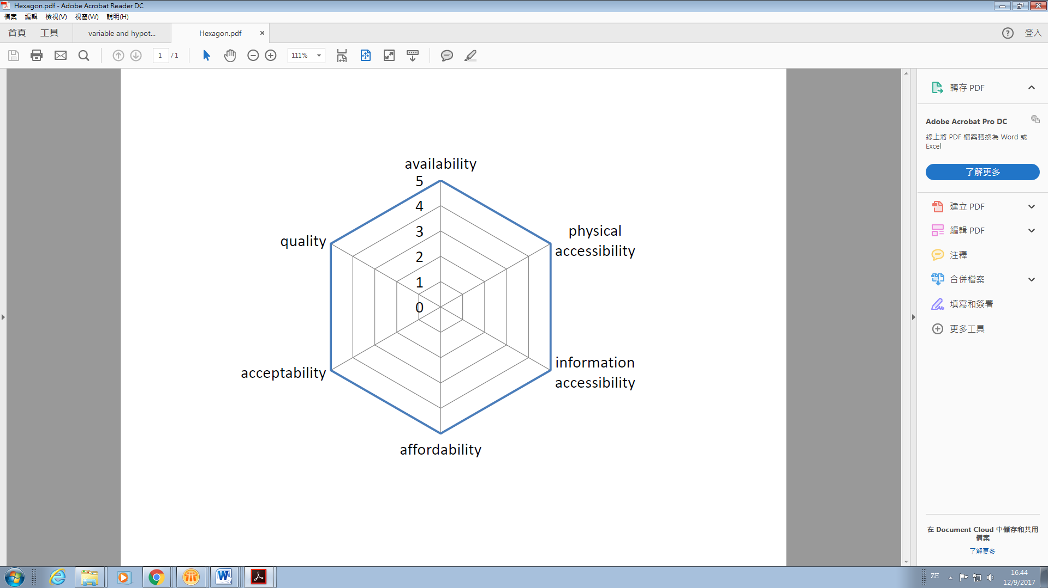

*(Art 26 UDHR; Art 13-14 ICESCR; Art 137 BL)*

**3.5** Right to education

|  |  |
| --- | --- |
| Art 26 UDHR | (1) Everyone has the right to education. Education shall be free, at least in the elementary and fundamental stages. Elementary education shall be compulsory. Technical and professional education shall be made generally available and higher education shall be equally accessible to all on the basis of merit.  (2) Education shall be directed to the full development of the human personality and to the strengthening of respect for human rights and fundamental freedoms. It shall promote understanding, tolerance and friendship among all nations, racial or religious groups, and shall further the activities of the United Nations for the maintenance of peace.  (3) Parents have a prior right to choose the kind of education that shall be given to their children. |
| Art 13 ICESCR | 1. The States Parties to the present Covenant recognize the right of everyone to education. They agree that education shall be directed to the full development of the human personality and the sense of its dignity, and shall strengthen the respect for human rights and fundamental freedoms. They further agree that education shall enable all persons to participate effectively in a free society, promote understanding, tolerance and friendship among all nations and all racial, ethnic or religious groups, and further the activities of the United Nations for the maintenance of peace.  2. The States Parties to the present Covenant recognize that, with a view to achieving the full realization of this right:  (a) Primary education shall be compulsory and available free to all;  (b) Secondary education in its different forms, including technical and vocational secondary education, shall be made generally available and accessible to all by every appropriate means, and in particular by the progressive introduction of free education;  (c) Higher education shall be made equally accessible to all, on the basis of capacity, by every appropriate means, and in particular by the progressive introduction of free education;  (d) Fundamental education shall be encouraged or intensified as far as possible for those persons who have not received or completed the whole period of their primary education;  (e) The development of a system of schools at all levels shall be actively pursued, an adequate fellowship system shall be established, and the material conditions of teaching staff shall be continuously improved.  3. The States Parties to the present Covenant undertake to have respect for the liberty of parents and, when applicable, legal guardians to choose for their children schools, other than those established by the public authorities, which conform to such minimum educational standards as may be laid down or approved by the State and to ensure the religious and moral education of their children in conformity with their own convictions.  4. No part of this article shall be construed so as to interfere with the liberty of individuals and bodies to establish and direct educational institutions, subject always to the observance of the principles set forth in paragraph I of this article and to the requirement that the education given in such institutions shall conform to such minimum standards as may be laid down by the State. |
| Art 14 ICESCR | Each State Party to the present Covenant which, at the time of becoming a Party, has not been able to secure in its metropolitan territory or other territories under its jurisdiction compulsory primary education, free of charge, undertakes, within two years, to work out and adopt a detailed plan of action for the progressive implementation, within a reasonable number of years, to be fixed in the plan, of the principle of compulsory education free of charge for all. |
| Art 137 Basic Law | Educational institutions of all kinds may retain their autonomy and enjoy academic freedom. They may continue to recruit staff and use teaching materials from outside the Hong Kong Special Administrative Region. Schools run by religious organizations may continue to provide religious education, including courses in religion.  Students shall enjoy freedom of choice of educational institutions and freedom to pursue their education outside the Hong Kong Special Administrative Region. |

The modern debate on how to educate and to what ends has its origin in the liberation process (from the strict controls by the Church and feudal lords) which culminated in the Enlightenment. As a result, education, its methodologies and aims, increasingly received philosophical and political consideration.

Education is a prerequisite for the human being to understand the outside material world and to seek and develop his or her identity as an autonomous human being, endowed with a unique personality and dignity. It is therefore the bedrock of humanity, providing empowerment and skills that strengthen the individual capacity to enjoy the full range of other human rights.

Education is in addition an indispensable means to combating poverty. Once educated, economically and socially marginalized adults and children have a chance of lifting themselves out of poverty and also obtain the tools to participate meaningfully in their communities. Education is therefore one of the best financial investments a government can make in its development.

The right to education entails different obligations in relation to primary, secondary and higher education.

1. Primary education

There is an immediate duty for the government to introduce primary education that is compulsory and free of charge for all.

1. Secondary education

Secondary education on the other hand must be made generally available and accessible to all. This means that secondary education must be available on the same basis to all, independent of a student's apparent capacity or ability, the ultimate aim being the introduction of free and universal secondary education.

This universalist (albeit not immediately realizable) character means that secondary education should not be aristocratic. For example, if extreamly high fees are imposed by private schools, leaving the chances of students entering these schools determined by the parents’ financial ability, then it may constitute a violation of the right to education.

The Government should therefore offer financial assistance, including but not limited to subsidies for textbooks, school kits and aids, and increased scholarships, to low-income families to cover the associated expenses of education;

1. Higher education

Higher education, whilst not to be ‘generally available’ as being a more advanced stage of academic development, should progress towards free provision, on the basis of the capacity of students. Again, financial obstacles which deny otherwise qualifying grassroots students access to free higher educational institutions, with detrimental consequences for their upward social mobility, may violate the right to education.

As such, the government will be well-advised to increase the number of places of first year entrance for university programmes, and introduce a reduction of fees in higher education with a view to abolishing them, and by all other appropriate means, in particular through a comprehensive system of adequate study grants, to guarantee for applicants from lower-income families access to higher education;

See further Committee on Economic, Social and Cultural Rights, *General Comment No 13* (1999).

**Question to consider:**

**The right to education is closely related to the right to equality of opportunities (discussed in Lesson Four). With a good and fair education system, students from poor families will still receive high quality education and climb up the social ladder after they graduate. It is therefore widely believed that the right to education is significant to enhancing social mobility. However, in recent years, there has been a widespread perception that Hong Kong’s education system has failed to promote equality of opportunities, and that students from wealthy families always “win at the starting point”. What is the basis of such criticism? If such criticism is a justified one, how should the education system be reformed?**

See American Psychological Association, *Education and Socioeconomic Status Factsheet*, available at [www.apa.org/pi/ses/resources/publications/education.aspx](http://www.apa.org/pi/ses/resources/publications/education.aspx)

**3.6** Right to housing

*(Art 25 UDHR; Art 11 ICESCR)*

|  |  |
| --- | --- |
| Art 25 UDHR | (1) Everyone has the right to a standard of living adequate for the health and well-being of himself and of his family, including food, clothing, housing and medical care and necessary social services, and the right to security in the event of unemployment, sickness, disability, widowhood, old age or other lack of livelihood in circumstances beyond his control.  (2) Motherhood and childhood are entitled to special care and assistance. All children, whether born in or out of wedlock, shall enjoy the same social protection. |
| Art 11 ICESCR | 1. The States Parties to the present Covenant recognize the right of everyone to an adequate standard of living for himself and his family, including adequate food, clothing and housing, and to the continuous improvement of living conditions. The States Parties will take appropriate steps to ensure the realization of this right, recognizing to this effect the essential importance of international co-operation based on free consent.  2. The States Parties to the present Covenant, recognizing the fundamental right of everyone to be free from hunger, shall take, individually and through international co-operation, the measures, including specific programmes, which are needed:  (a) To improve methods of production, conservation and distribution of food by making full use of technical and scientific knowledge, by disseminating knowledge of the principles of nutrition and by developing or reforming agrarian systems in such a way as to achieve the most efficient development and utilization of natural resources;  (b) Taking into account the problems of both food-importing and food-exporting countries, to ensure an equitable distribution of world food supplies in relation to need. |

In Lesson Two, we have seen that the right to privacy protects the sanctity of the home. It presupposes that the individual has a home to start with. That cannot, however, be taken for granted. In this day and age, the right to adequate housing continues to be threatened, even in Hong Kong.

The right to adequate housing is a central element of the wider right to a dignified standard of living. It is therefore not a narrow or restrictive right that only guarantees having a roof over one's head; rather, it should be seen as the right to live somewhere in security, peace and dignity.

As such, for there to be “adequate housing”,

* There should be available services, materials, facilities and infrastructure that are essential for health, security, comfort and nutrition;
* Housing itself must be affordable for all;
* Habitability is important, ie inhabitants should be able to enjoy adequate space and protected from cold, damp, heat, rain, wind or other threats to health;
* Housing should be equally accessible, and give disadvantaged groups a real choice, in that a country or region should, so far as it is possible, help households with a lower economic and social status in securing a place, in reasonable proximity to where they carry out their normal activities, so that they can live in peace and dignity.

With the full realization of the right to adequate housing in view, the government has a duty to ‘take whatever steps are necessary’ to provide assistance to individuals to satisfy their basic housing needs.

**Question to consider:**

**Up to 10500 households in Hong Kong are estimated, by the Hong Kong Government’s definition, to be living in “inadequately housed households”, including “subdivided units”, commonly understood as meaning individual living quarters having been subdivided into two or more smaller units for rental. Many such households are living in old buildings with crowded living environment, poor hygiene conditions and a lack of fire prevention facilities. These are also typically low-income households, who by reason of their limited financial resources have had no real free choice as to where they live, and in what conditions.**

**This is in part the result of the consistently low housing supply in Hong Kong. As at end-September 2016, there were about 152 500 general applications for public rental housing, and about 134 000 non-elderly one-person applications. Even so, the government has only undertaken to provide an average of no more than 20,000 public rental housing units per year in the years to come, an aim that can hardly answer the current housing demands and will only serve to further lengthen the existing Waiting List. Many of the applicants on the Waiting List are, in the nature of things, those very SDU residents who have to live in exceptionally poor housing conditions.**

**Does this state of affairs in Hong Kong amount to a violation of the right to adequate housing? If so, what can the government do in the short and long term to redress the violation?**

**(Note:**

**Such poor living conditions are decidedly akin to the conditions of cage homes in Hong Kong which the Committee deplored in 1996: CommESCR, ‘Concluding Observations of the Committee on Economic, Social and Cultural Rights: United Kingdom of Great Britain and Northern Ireland (Hong Kong)’ (6 December 1996) UN Doc E/C.12/1/Add.10 para 29. Sub-divded Units, by their inadequacy as a form of housing, are as much ‘an affront to human dignity’ as are bed-space apartments or cage homes. The fact that it is generally persons on low incomes who having to live in such substandard conditions, as a result of the consistently insufficient provision of social housing in Hong Kong worsens the matter.**

**As such, the government’s failure to provide adequate and suitable housing choices to those on low incomes, occasioned by the government’s policy and planning in the past and their serious shortcomings, amounts to a violation of the right to housing, particularly in the light of the general principle that “the right to [adequate] housing should be ensured to all persons irrespective of income or access to economic resources”.**

**The government should (by way of examples)**

* **set up a detailed regulatory framework to address the problem of inadequate housing, exemplified by Subdivided units, with a view to improving the quality of accommodation;**
* **reconsider its housing policies, develop effective strategies (including but not limited to the reinstatement or improvement of the social housing programmes), and take all appropriate steps, as a matter of priority, to ensure that sufficient resources commensurate with the extent of the housing shortage are set aside for increasing the availability of affordable and adequate housing, taking into special consideration the needs of the disadvantaged and marginalised individuals and groups;**
* **provide appropriate forms of financial support, such as access to credit and housing subsidies, for low-income families and marginalised and disadvantaged groups;**
* **legislate to give specific legal enforceability to the right to affordable housing so that aggrieved individuals can seek redress from the government in courts.**

Transport and Housing Bureau, *Long Term Housing Strategy Annual Progress Report 2016* (December 2016), available at <http://www.thb.gov.hk/eng/policy/housing/policy/lths/LTHS_Annual_Progress_Report_2016.pdf>

運輸及房屋局，《長遠房屋策略》 2016 年周年進度報告 （2016 年12月）

<http://www.thb.gov.hk/tc/policy/housing/policy/lths/LTHS_Annual_Progress_Report_2016.pdf>

**3.7** Right to culture

*(Art 27 UDHR; Art 15 ICESCR; Art 34, 40)*

|  |  |
| --- | --- |
| Art 27 UDHR | (1) Everyone has the right freely to participate in the cultural life of the community, to enjoy the arts and to share in scientific advancement and its benefits.  (2) Everyone has the right to the protection of the moral and material interests resulting from any scientific, literary or artistic production of which he is the author. |
| Art 15 ICESCR | 1. The States Parties to the present Covenant recognize the right of everyone:  (a) To take part in cultural life;  (b) To enjoy the benefits of scientific progress and its applications;  (c) To benefit from the protection of the moral and material interests resulting from any scientific, literary or artistic production of which he is the author.  2. The steps to be taken by the States Parties to the present Covenant to achieve the full realization of this right shall include those necessary for the conservation, the development and the diffusion of science and culture.  3. The States Parties to the present Covenant undertake to respect the freedom indispensable for scientific research and creative activity.  4. The States Parties to the present Covenant recognize the benefits to be derived from the encouragement and development of international contacts and co-operation in the scientific and cultural fields. |
| Art 34 Basic Law | Hong Kong residents shall have freedom to engage in academic research, literary and artistic creation, and other cultural activities. |
| Art 40 Basic Law | The lawful traditional rights and interests of the indigenous inhabitants of the "New Territories" shall be protected by the Hong Kong Special Administrative Region. |

The modern notion of “culture” is a historically created system of beliefs and practices under which a group of people understand and organize their lives, both individually and in relation to each other. It is only with culture that self-identity is formed, through shared experiences, history, and practices lived in the community.

Each individual is therefore entitled to the "cultural rights indispensable for his dignity and free development of his personality”: Article 22 *UDHR*, and should be free “to participate in the cultural life of the community, to enjoy the arts and to share in scientific advancement and its benefits”: Article 27 *UDHR*.

“Culture” here is a broad concept, encompassing various aspects of cultural life. They include ways of life, language, oral and written literature, music and song, non-verbal communication, religion or belief systems, rites and ceremonies, sport and games, methods of production or technology, natural and man-made environments, food, and clothing and shelter and arts, customs and traditions.

In particular, having full access to cultural heritage is the hallmark of belonging to a community and being a member of society. Cultural heritage links the past to the present and the future. It is important to the transmission of cultural identity, from the old to younger generations, for the community to be able to visit a historical site, to physically be in a spiritually significant site, and to teach the children about the historic and cultural landscapes. Conversely, if heritage sites are destroyed or otherwise interfered with, the cultural survival of a community may be undermined and inhibited.

Thus, the right to cultural life guarantees access to, and protection of, the "heritage of the past, . . . particularly ancient monuments and traditions which may contribute to the essential equilibrium of societies": *UNESCO Recommendation on Participation in Cultural Life* (1976). The government has the duty to enact legislation to ensure that cultural heritage is preserved and maintained.

Further, and more generally, the government must adopt non-discriminatory strategies and policies to ensure the access to facilities such as museums, libraries, and other cultural sites, and include cultural education in school curricula, in consultation with all those concerned.

See further Committee on Economic, Social and Cultural Rights, *General Comment No 21* (2009).

Case Study (2)：The Housing problem in Hong Kong

The following picture is from the report of *HK01*, reporting how tough the living environment of the “Sub-divided flats” (劏房) is.

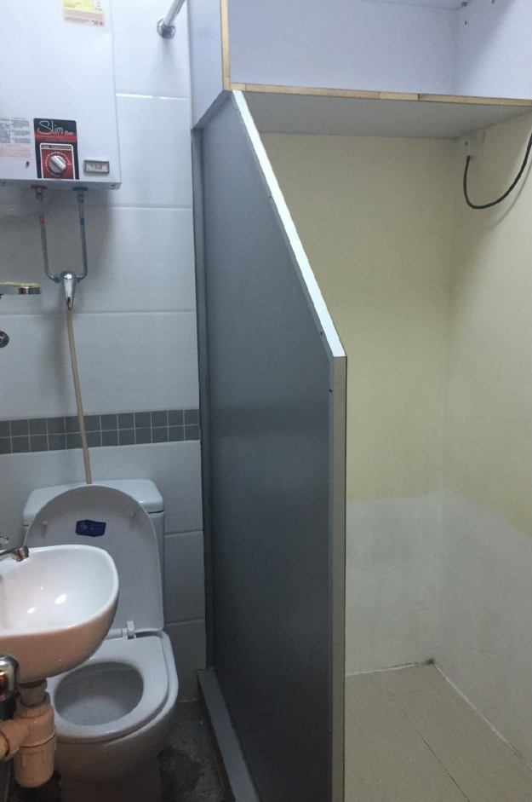

And the report says:

「廁所劏房」主要由兩部分構成，中間設圍板作分隔，左邊為馬桶、洗手盤及花灑，即大小二便、刷牙及洗澡都要在此範圍內進行；而右邊則是一個約155厘米ｘ75厘米的空間，用以擺放睡床，但最多只放得下一張2呎半的床，而一般成年男人身高來算，需要蜷曲身體才可容得下。

「影子長策會」成員陳紹銘指，該劏房呎租逾60元，「貴過唔少豪宅」，批評劏房住屋環境不人道，「對住廁所好誇張，喺嗰度食嗰度痾」。陳紹銘續指，此類租盤近年越見普遍，意味政府房屋政策出現甚大問題。他指出，現時公屋數量不足，單身人士難以上樓，唯有無奈入住劏房；加上政府未設立租金管制，變相鼓勵業主多將房屋「劏細」，務求收取更高租金。

Source: <https://www.hk01.com/%E7%86%B1%E8%A9%B1/35351/-%E7%9B%B4%E6%93%8A-%E6%9C%89%E7%89%87-%E8%91%B5%E6%B6%8C30%E5%91%8E-%E5%BB%81%E6%89%80%E5%8A%8F%E6%88%BF-%E6%9C%88%E7%A7%9F2%E5%8D%83%E9%A6%AC%E6%A1%B6%E7%82%BA%E4%BC%B4>

Teacher may ask student to think about if this kind of sub-division house is acceptable at all, in terms of living space, hygiene, etc. If not, we can understand why a reasonable housing is too a basic human right.

**© Dan Jones**

***Learning Activity 3***

***Human rights on the street***

***學習活動三***

***人權就在街上***

Identify examples of rights being demanded, exercised and denied in the *Right up your street* illustration of the previous page. Record your findings in the relevant columns on the table below, referring to the relevant scene from the illustration. One example is done for you.

|  |  |  |
| --- | --- | --- |
| A right demanded | A right exercised | A right denied |
| Somebody is asking for  their human rights to be  respected | Somebody is using or  enjoying a human right | Somebody is abusing  somebody else’s human  rights |
|  | EXAMPLE: The right to an  education (Protocol 1, Article  2) – children in the primary  school |  |
|  |  |  |
|  |  |  |
|  |  |  |
|  |  |  |
|  |  |  |
|  |  |  |
|  |  |  |

***Learning Activity 4 Relation table of Human Right***

Human rights are interrelated. Denial of one human will undermine the realization of another. Listen to the cases raised by your teacher and infer the consequences in the boxes provided.

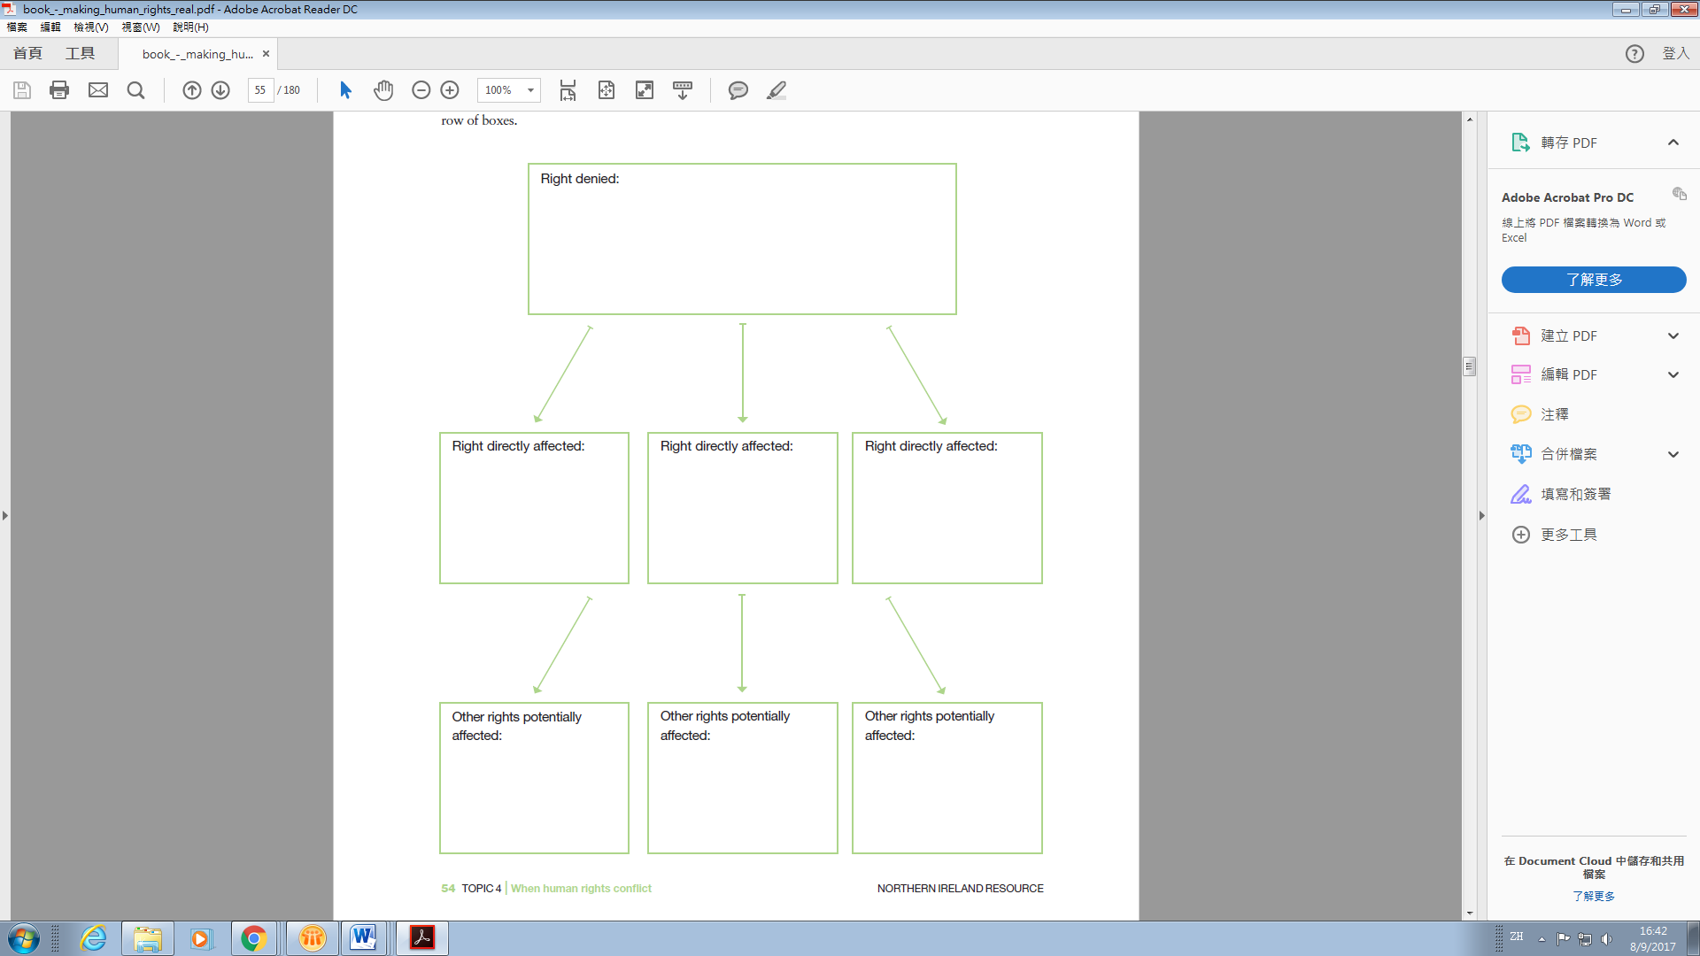

Activities used with permission from [www.amnesty.org.uk/education](http://www.amnesty.org.uk/education).