Human Rights
Lesson Four:
Discrimination
Personal, Social and Humanities Education
Education Bureau
2017

Learning Objectives

Knowledge
- Understand roots of discrimination
- Realise different manifestations of discrimination
- Investigate some examples of discrimination
- Handle conflict of human rights
Skills
- Critical thinking skill
- Communication skill

Values and Attitudes
- Rational
- Rules of Law
- Fair and Justice
Equality and non-discrimination are one of the core architectural principles of human rights. Indeed, the idea that humanness by itself forms the basis of basic rights necessarily implies equality of all human beings in those rights.

Learning Activity 1

Identify the main roots of discrimination from the dialogue below.

Property agency: Mr Chan, we would like to recommend a tenant for you. He is willing to pay your asking rent.
Mr Chan: Good! Tell me the details.
Property agency: The tenant is a Pakistani. He needs an apartment for his family with 3 children.
Mr Chan: Wait! A Pakistani? I don’t want to lease my apartment to a Pakistani.
Property agency: But he is the only one who is willing to accept your asking price.
Mr Chan: These people are very dirty and rude. They will leave the house messy and smelly when they leave. You know my flat is nicely decorated with designer chairs and fine furniture. Do you think this Pakistani is able to appreciate them use them gently? In fact, I doubt if they can pay rent on time every month. My apartment is a quality property in a famous estate, are you sure that your recommended client has the financial ability to pay the rent? What if they refuse to pay after the first month? How am I going to chase after them? They have no sense of rule of law at all! Don’t forget that they have strong bodies with big beard…
Property agency: Mr Chan, I understand what you mean. This time is different. The client says that he is willing to pay the whole year rent in a lump sum when signing the contract. So there is no worry about the rent.
Mr Chan: That sounds even more suspicious! Where did his money come from? Maybe he is engaged in illegal activities.
Property agency: Alright, Mr Chan, I have got your points.

A make up dialogue
On an abstract level, the principles of equality and non-discrimination are almost universally approved and recognised. In the real world, however, discrimination persists. It typically arises from the stereotyping, prejudice, ignorance, fear, or sense of superiority prevailing in societies, simply because an individual possesses certain personal characteristics or circumstances of which it is either impossible or inequitable to change or removal (such as race or gender). Often, a group, whose members are diverse, is unfairly and grossly inaccurately portrayed as possessing undesirable traits associated with their personal characteristics (for example, “all persons of a certain skin colour are less intelligent”).

In truth, someone’s personal characteristics, whether they be race, gender, marital status or sexual orientation, indicates nothing about his or her attitudes or potential. It is a "false measure of individual worth, one unfair and oppressive to the person concerned, one harmful to others because discrimination causes a grave and recurring injury upon society as a whole: Gay Rights Coalition v Georgetown University, 536 A 2d 1 (DC 1987). To base differences of treatment on such false assumptions of intrinsic worth inflicts a personal injustice inasmuch as it stigmatizes the victim as inferior and robs them of their deserved dignity. The discriminated groups would have to labour under misinformed stereotypes, unable to live out their full potential. Society, in turn, would be denied the benefits of wide participation and the talents of individuals who just happened to be a member of a minority group.

Of course, discrimination, being toxic, does not only occasion dignitary or psychological harm, especially if it is state-sponsored. One recalls how the Nazis in the early 1940s forced Jews to wear a yellow, palm-sized, six-pointed fabric “star of David” on their clothing whenever they appeared in public, and encouraged private citizens to identify, and thus single out or persecute, Jews. When the government condones or actively supports discriminatory conduct motivated by distorted beliefs about individuals based on stereotypes, it legitimates and amplifies the divisiveness in and the harm done to society.

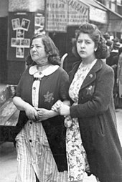
Thus international human rights instruments all explicitly list as prohibited grounds of discrimination race, colour, sex, language, religion, political or other opinion, national or social origin, property, birth or other status. These are characteristics which involve the respect and dignity that society accords to a human being. They are fundamental societal values: see Fok Chun Wa v Hospital Authority (2012) 15 HKCFAR 409.

Picture from open source
However, the list is not closed but is expanding, in recent years having included, for example, disability, sexual orientation and age: see eg Committee on Economic, Social and Cultural Rights, General Comment No 20 (2009).
4.1Different types of discrimination

Discrimination can manifest itself in at least three ways:
- Direct discrimination: putting an individual under a disadvantage overtly (and often intentionally) because of his or her minority traits or identity
eg An employer refuses to employ a woman because she is of the female sex.

- Indirect discrimination: applying a facially neutral requirement which has a (sometimes unintentional) particularly disadvantageous effect on a minority
eg An employer refuses to employ a woman because she fails to meet the requirement of having a low-pitched voice. (Whilst the possibility that some women may be able to meet the requirement cannot be excluded, the requirement would have the disparate effect on the majority of women.)

- Action or speech that perpetuates stigma, stereotyping, prejudice, and violence (which may in some circumstances overlap with direct or indirect discrimination)

Eg Hate speech, harassment or violence against racial minorities

4.2Ways of conceptualising “equality”

Correspondingly, there are at least four ways of conceptualising “equality”:

- Equal treatment
- Equality of opportunities
- Equality of results
- Protection of human dignity and elimination of prejudice

To be sure, these four different conceptions are by no means mutually exclusive, but can and do overlap in ways that complement each other.

- Equal treatment

The simplest understanding of “equality” is that “likes should be treated alike”. The same set of criteria is used to judged everyone, whether you are in the majority or in the minority. Thus, generally speaking, a black person (or a woman) who is doing work of equal value with a white person (or a man) should be entitled to equal pay, and employers should not require a woman to do more onerous work than do a man when the jobs of each are of objectively the same nature.

Important though it certainly is, to take “equality” as “equal treatment” in every comparable case is however inadequate. It only addresses direct discrimination, ie explicit discrimination or unfavourable treatment.

When there is antecedent or structural inequality, “equal treatment” might only serve to entrench the unequal situations between the minority and the majority. For example, it is meaningless to say that both men and women are equally qualified for a job as long as they have graduated from secondary school, if girls in a certain country are never allowed to go to school.
As such, this conception of equality would be inapt to address indirect discrimination.

- Equality of opportunities
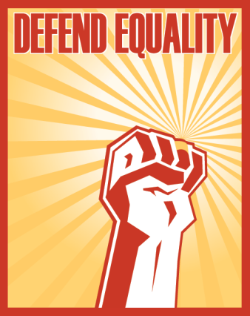
Whereas “equal treatment” reflects the notion of consistent treatment, the “equality of opportunities” approach seeks to ensure that everyone in the race begins from the same starting point. The idea is that structural barriers should be removed to open up opportunities for minorities, so that all can be judged solely according to their merits regardless of their majority or minority status. One example of this would be to require that employers look only at the merits of the job applicants, and refrain from applying unreasonable and discriminatory criteria (such as strength for women applicants when the job’s nature does not demand physical fitness), even though such criteria do not explicitly refer to minority statuses.

Whilst well-intentioned and indeed a significant advancement in the understanding of equality, “equality of opportunities” addresses mostly procedural obstacles in the way of minorities and may not always lead to substantive equality. It would of course be a much fairer system if, for example, job applicants need only compete with each other on their merits, but the concept of “merits” itself is also a possible cause of past discrimination.

Consider members of the black community in the United States. They typically come from poor households and have limited educational resources due to the historical discrimination and exclusion the black community had to endure. As a result, the chances that they had in going to prestigious universities – if they managed to get to universities at all – were starkly worse than their white counterparts. Many women are in much the same situation because for cultural reasons. Parents (especially those with modest means) tend to send their sons rather than their daughters to school. In such circumstances, insisting on merits across the board without giving due consideration to these realities cannot perfectly guarantee true equality.

“[I]t is not enough just to open the gates of opportunity. All our citizens must have the ability to walk through those gates.”

- Lyndon Johnson, former President of the United States, in 1965

- Equality of results

An alternative account of “equality” is therefore “equality of results”, which is concerned with end results and a fairer distribution of benefits.

More capable of addressing antecedent inequality, the principle of “equality of results” permits or even requires preferential treatment of a disadvantaged minority in order to achieve equal results. This is what is sometimes called “affirmative action” or “reverse discrimination”. It means that measures are taken to redress the disadvantages experienced by minority groups, such that there is equitable representation in, for example, all occupational categories and levels in the workforce. The aim is to proactively advance individuals or groups of individuals disadvantaged by unfair discrimination.

Eg Policies of some companies that if there are two equally qualified job applicants, and one of them belongs to a minority group, then the minority applicant would be selected.

- Protection of human dignity and elimination of prejudice

As stated in Lesson One, human dignity is often taken as the foundation of all human rights. Logically, human dignity must also constitute the core of the right to equality, itself a human right. This is the dimension of equality which speaks to our basic humanity. Equality is a right for everyone, not because of their individual merit, but because of their being human. No one should be humiliated or degraded through racism, sexism, violence, or other status-based prejudice.

Accordingly, treatment that may be inconsistent with the principles of “equal treatment”, “equal opportunities” and “equal results” (ie no relative disadvantage between the “majority” and “minorities”) are unacceptable because they undermine human dignity.

“Equality means that our society cannot tolerate legislative distinctions that treat certain people as second class citizens, that demean them, that treat them as less capable for no good reason, or that otherwise offend fundamental human dignity.”

- Supreme Court of Canada in Law v Canada (1999).

For example, “racial segregation” does not become legitimate just because every racial group is “equally” segregated and excluded from each other. Equality embodies the concept of human dignity and cannot have the effect of rendering everyone a victim of discrimination.

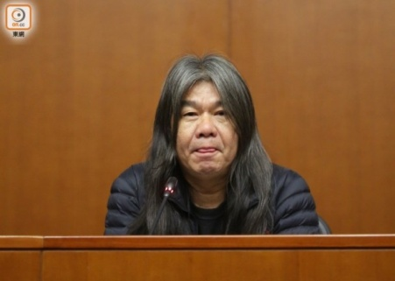
(Consider some of the social reactions to Leung Kwok Hung also known as "Long Hair" v Commissioner of Correctional Services (2017), where the court held that male prisoners should not be discriminated against for preferring to have their hair longer than is usually considered normal. Is the problem solved simply by cutting off female prisoners’ hair as well, so that everyone suffers the same degree of disadvantage? Is that “equality”?)

There are other acts or speech which has nothing to do with relative disadvantage as such (because they do not involve comparison with the majority) but would violate the right to equality. Examples include hate speech which spreads hate and incites violence against a minority group in society. The right to equality, properly understood, requires the government to prohibit this kind of hate speech and impose severe punishment on offenders who assault members of minority groups in order to deter similar prejudice-based offences from happening again in the future.

More generally, the government has the responsibility to promote a general climate of societal openness and tolerance by providing fair information about different minorities as part of the school curriculum, by facilitating visibility of minority groups (eg actively helping them set up NGOs in the exercise of their freedom of association) and by encouraging communication between minorities and society as a whole.

Further Readings

See further Sandra Fredman, 'Substantive equality revisited' (2016) 14 International Journal of Constitutional Law 712-738;

United Nations Committee on Economic, Social and Cultural Rights, General Comment No 20 (2009).

Altman, Andrew, "Discrimination", The Stanford Encyclopedia of Philosophy (Winter 2016 Edition), Edward N. Zalta (ed.), URL = <https://plato.stanford.edu/archives/win2016/entries/discrimination/>.

Consider the following scenarios. Which form(s) of discrimination is(are) involved and how the different conceptions of equality can help us address the discrimination?
- The education authorities of City A introduced a Secondary School Places Allocation system under which a girl must have scored higher marks in the examinations than a boy in order to get into her preferred top band. The system was based on the misinformed and factually false stereotype that girls’ brains matured earlier than boys’.
Faced with criticisms that the system was discriminatory, the education authorities revised the system such that now Secondary School Places Allocation would be determined by the height of each Primary Six pupil: the taller the better are their chances of getting into their preferred bands.

(Note:
Before revision – direct discrimination against girls, because of less favourable treatment overtly owing to sex of the student; discriminatory stereotype might lead to prejudice against prepubertal boys.

After revision – indirect discrimination against boys, because a statistically significant proportion of boys would be disadvantaged, given that the pubertal growth spurt (in height, weight etc) generally begins earlier for girls than for boys: see Ashraf Soliman, Vincenzo De Sanctis, Rania Elalaily, and Said Bedair, 'Advances in pubertal growth and factors influencing it: Can we increase pubertal growth?' (2014) 18 Indian Journal of Endocrinology and Metabolism S53)

Solutions – a non-gender based system (equal treatment) which allows girls and boys compete, at least at the stage of allocation, at the same starting line (equal opportunities); government should intensify efforts to eliminate stereotypes depicting prepubertal boys as inferior in intellect (dignity)

Based partially on Equal Opportunity Commission v Director of Education [2001] 2 HKLRD 690

- The criminal laws of City A prohibited homosexual conduct between men or between women, because it was believed that homosexuals were all paedophiles and therefore deserved to be punished severely. Heterosexual conduct between a man and a woman was not prohibited in any circumstances, even if non-consensual, because it was believed that women were all submissive and would always consent to sexual advances by men.

(Note:
Direct discrimination against homosexual men and women on the ground of sexual orientation/

Discriminatory stereotypes about both homosexual men and women and heterosexual women.)

Solutions – decriminalization subject to equal age of consent; punishment of criminals of non-consensual sex; government efforts to eliminate stereotypes about homosexuals and women by public education etc.

- The government of City A planned to set up Integrated Community Centre for Mental Wellness within a housing estate. A District Councillor put up a banner saying “No Mental Illness Centre; stay out of our neighbourhood!”, “Strongly protest against the government’s disregard for the residents’ safety!” and “Mental Illness Centre may create scare among residents!”. The Integrated Community Centre were eventually set up at the designated site.

(Note:
No direct or indirect discrimination as there have been no relative disadvantage.

Hate speech stirring up hatred, serious contempt and/or severe ridicule against persons with mental disabilities/illnesses, because the banners, by saying that such persons should stay out of the neightbourhood, effectively labelled such persons as a danger to society that must be shunned.)

Solution – government efforts to eliminate stereotypes about persons with mental disabilities/illnesses.

Based on Tung Lai Lam 對 梁健文 (DCEO 1/2011, 19 April 2013))

- The government of City A decided to make pregnant women who are visitors to the city to pay a substantially higher level of fees for giving birth in public hospitals than the local resident women.

(Note:
Direct discrimination on the basis of residence type, but justified because a lot of public resources are at stake, and residence type is not an innate characteristic comparable to race, gender, sexual orientation etc)

Case study (1): Gay Marriage Wedding Cake in Colorado USA

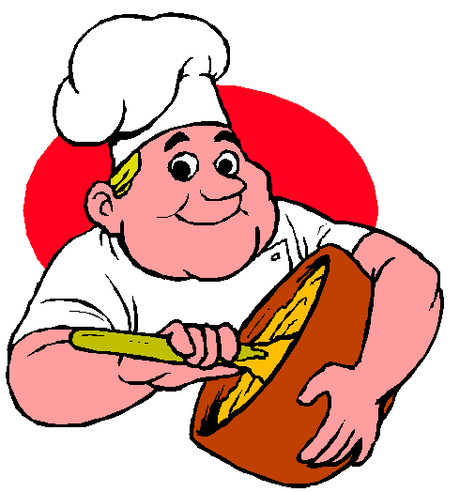
David Mullins and Charlie Craig visited Masterpiece Cakeshop last year, to order a cake for their upcoming wedding reception. The cake shop owner Jack Phillips informed them that because of his religious beliefs the store’s policy was to deny service to customers who wished to order baked goods to celebrate a same-sex couple’s wedding.

Longstanding Colorado state law prohibits public accommodations, including businesses such as Masterpiece Cakeshop, from refusing service based on factors such as race, sex, marital status or sexual orientation.

Same-sex marriage has been legally recognized in Colorado since October 7, 2014.

- Analyze the case from the perspective of human rights.
- Make a moral judgment on the action of the cake shop owner.
- How to tackle the problem of conflict of human rights? (ie the right to practice religion vs right to receive equal service / right to dignity)

Source: http://aclu-co.org/court-rules-bakery-illegally-discriminated-against-gay-couple/
Further readings：
Sandra Fredman, 'Substantive equality revisited' (2016) 14 International Journal of Constitutional Law 712-738;

United Nations Committee on Economic, Social and Cultural Rights, General Comment No 20 (2009).

Altman, Andrew, "Discrimination", The Stanford Encyclopedia of Philosophy (Winter 2016 Edition), Edward N. Zalta (ed.), URL = <https://plato.stanford.edu/archives/win2016/entries/discrimination/>.

Adverse effect of a practice or standard that is neutral and non-discriminatory in its intention but, nonetheless, disproportionately affects individuals having a disability or belonging to a particular group based on their age, ethnicity, race, or sex.

