Human Rights

Lesson One: Inherent Dignity

**Learning objectives**

**Knowledge**

1. Understand what human rights are
2. Understand why human rights should be respected
3. Comprehend how human rights form an essential constituent or characteristic of being human
4. Study situations which deny inherent dignity

**Skills**

1. Critical Thinking Skills

**Values and Attitudes**

1. Rational
2. Rules of Law
3. Fair and Justice

**Warming up activity:

What basic human rights are represented by these symbols?

(Students may answer.)

* *a tent ( ),*
* *an umbrella( ),*
* *a plate with food ( ),*
* *a book ( ),*
* *a teddy bear ( ),*
* *a flag ( ),*
* *a first aid kit ( ),*
* *an envelope ( ),*
* *a house ( ).*
* *The globe may stand for ( )*

In what circumstances will these rights be deprived and by who?

**Warming up activity:

What basic human rights are represented by these symbols?

(Students may answer.)

* *a tent (leisure),*
* *an umbrella(protection),*
* *a plate with food (physical needs),*
* *a book (education, freedom of thought),*
* *a teddy bear (leisure and play),*
* *a flag (protection of citizen’s rights by the state),*
* *a first aid kit (medical care),*
* *an envelope (freedom of communication and expression),*
* *a house (right to family, right to house or privacy).*
* *The globe may stand for (the idea of protecting human rights for every human being).*

In what circumstances will these rights be deprived and by who?

***1* Introduction**

Human rights are norms that help to protect individuals from abuses by others, especially the state machinery. Not only do human rights impose negative duties which prohibits duty bearers from doing something (such as the prohibition of discrimination based on gender, race, political opinion and so on), but they may also impose positive duties which requires duty bearers to take action to give effect to the right (such as the duty to provide public education and healthcare services).

How the boundaries of human rights are drawn determines what kind of society we are establishing. In order to draw the boundaries of human rights properly, we need to first understand its normative basis. In this lesson, we will learn:

1. Inherent dignity as the normative basis of human rights recognized by the United Nations and international legal documents;

and

1. How do some Asian Cultures see it differently;



**Learning Activity 1 What are human rights ( I )**

True or false?

Students complete the following question individually. After everyone has finished, all stand up and the teacher check the answers with class. Sit down when one error is found and those remain standing at last win.

|  |  |
| --- | --- |
|  | True/False |
| The right to play is a human right. |  |
| The right to marriage is a human right. |  |
| Copyright is a human right. |  |
| Voting right is a human right. |  |
| Dignity is a human right. |  |



Key

1. True
2. True
3. False
4. True
5. True

**1.1Inherent Dignity**

The United Nations has always recognized the inherent dignity of human beings as the normative basis of human rights. For instance, the International Covenant on Civil and Political Rights (ICCPR) of 1966 declares in its Preamble that “recognition of the inherent dignity and of the equal and inalienable rights of all members of the human family is the foundation of freedom, justice and peace in the world” and that these inalienable rights “derive from the inherent dignity of the human person”.

The expression “inherent dignity (or worth)” or “human dignity” also features prominently in:

1. International human rights instruments:
2. Universal Declaration of Human Rights; (UDHR, See page XX for a simplified version)
3. International Covenant on Civil and Political Rights
4. International Covenant on Economic, Social and Cultural Rights (ICESCR)
5. Convention on the Rights of the Child;
6. Convention Against Torture
7. Convention on the Elimination of All Forms of Discrimination against Women
8. International Convention on the Elimination of All Forms of Racial Discrimination
9. International Convention on the Protection of the Rights of All Migrant Workers
10. Convention on the Rights of Persons with Disabilities
11. National constitutions e.g. the Irish, German, South African and PRC Constitutions.

Thus, human dignity has become an important, even foundational, principle underlying the entire human rights discourse. At a level of abstraction, it can be posited that

1. every human being has an inherent dignity by virtue of his or her being human;
2. this inherent dignity demands that certain rights worthy of a human being should be protected;
3. hence, the concept of “human” rights.

**Learning Activity 2: What are human rights （II）**

There is a remote prison in a deserted island of 1000 miles distance from mainland. Only one prisoner is kept there for life imprisonment due to very cruel serial murders. He has completed voter registration before committing crimes. Should the government facilitate his voting in an election?

Think and discuss in pair. Teacher collects pros and cons arguments and reiterates the nature of human rights.

Or

Teachers may consider providing each student one of the following cards and require each of them to make use of the given source to come up with a judgement.

Banning the prisoner from voting would send society an educative message that only law-abiding citizens can make important decisions for the country. The ban would therefore deter potential criminals from committing crimes, and enhance civic responsibility and respect for the rule of law.

“All persons deprived of their liberty shall be treated with humanity and with respect for the inherent dignity of the human person.”

Article 10(1) of the International Covenant on Civil and Political Rights

“Denying citizens the right to vote runs counter to … the inherent worth and dignity of every individual.”

Supreme Court of Canada (in Sauvé v Canada (Chief Electoral Officer) (2002))

“The vote of each and every citizen is a badge of dignity and of personhood. Quite literally, it says that everybody counts”

Constitutional Court of South Africa in August v Electoral Commission (1999).

Since prisoners – especially those who only committed minor offences – are generally entitled to all their basic rights and personal dignity, except for those rights that imprisonment necessarily takes away (eg freedom to leave the prison as they wish, to meet whoever they want etc), they should generally still be able to enjoy the right to vote in principle, unless the government can otherwise justify its restriction based on convincing evidence that the public interest so requires.

“There is no convincing evidence that the aims of enhancing civic responsibility and respect for the rule of law can in fact be achieved by the blanket voting ban”

The Hong Kong Court of First Instance in Chan Kin Sum v Secretary of Justice (2009)

For essentially the same reasons (blanket voting ban cannot achieve respect for the rule of law and enhance civic responsibility), the United Kingdom courts (in Regina (Chester) v Secretary of State for Justice (2013)) and the European Court of Human Rights have confirmed that a blanket voting ban is contrary to the human rights and human dignity of the prisoners. The United Kingdom Government has so far refused to listen to the courts, and it has been heavily criticized by international organisations and human rights groups for this.

Those are the general principles. Exceptionally, however, the right to vote of prisoners who committed extremely serious crimes might be suspended without infringing human dignity.

The European Court of Human Rights held in Scoppola v Italy (No 3) (2013) that suspension of right to vote on the basis of serious criminal conduct would not be objectionable in itself, but such suspension must not be permanent and must be recoverable some time in the future.

In Hong Kong, the Legislative Council enacted the Voting by Imprisoned Persons Ordinance in 2009. The Ordinance now gives every prisoner – no matter how long their prison sentences are – the right to vote.

See further 《監獄剝奪的是自由還是人權？》on MingPao (1 September 2015) : <http://news.mingpao.com/pns/%E9%99%B3%E7%92%9F%E8%8C%B5%E3%80%81%E9%BB%83%E5%95%9F%E6%9A%98%E3%80%81%E7%AE%A1%E8%87%B4%E8%A1%8C%E3%80%81%E8%91%89%E6%89%BF%E6%98%8A%EF%BC%9A%E7%9B%A3%E7%8D%84%E5%89%9D%E5%A5%AA%E7%9A%84%E6%98%AF%E8%87%AA%E7%94%B1%E9%82%84%E6%98%AF%E4%BA%BA%E6%AC%8A%EF%BC%9F/web_tc/article/20150901/s00012/1441044108481)>

**Supplementary Case Study (Learning Objectives 2, 3, 4):**

The following story is told by Val Ginsburg, a Jew surviving the genocide in the Nazi time.

The Nazis immediately began to implement their racial laws against the Jewish population. They were deprived of every basic human rights. Jewish people were not allowed to walk on the pavement, use public transport, have a telephone, or even own pets. They had limited access to food, and constant hunger sapped their morale. The most terrifying thing was the constant arrests and executions. Within two months of the Nazi invasion, the 35,000-strong Jewish population of Kaunas had been reduced to 30,000.

On 15 August 1941 the Jewish population was crammed into a ghetto in a small suburb of Kaunas, surrounded by barbed wire and armed sentries. They had no fuel and barely any food. Val was sent out as a slave labourer and kept his remaining family alive by scrounging potato peel which his mother cleaned and cooked. Val's most upsetting memories are of the massacres: the 'Big Action', in which 10,000 people were taken away and shot, and the 'Children's Action' in spring 1944 when all the ghetto children, along with anyone who was old, sick or disabled, were forcibly taken away and murdered.

Teacher may, if judged appropriate, show videos related to the Nazi concentration camps, guiding student to feel uncomfortable and thus understand how horrible would be if human right is violated.

This real case study may be a supplement to the “imaged case” in activity 3.

Source: http://holocaustlearning.org/survivors/val-ginsburg

**1.2 Historic Context for the Development of Human Rights**

The recognition of inherent dignity as the source of human rights has to be understood in the context of the post-WWII world. After WWII, people started looking back to the history and studied the causes of WWII. It has been widely accepted that the war and the associated holocaust could be partly attributed to the lack of respect for human rights. It has also been recognized that there are human rights which should not be derogated on the ground of cultural, ethical, religious, and political traditions. Otherwise, political leaders may easily resort to different reasons to define human rights narrowly, leading to the vulnerability of human rights to manipulation by governments. Therefore, it was felt necessary to recognize inherent dignity as the source of human rights which can transcend cultural and political differences. It is universally applicable to every human beings and does not depend on which society one is in. In other words, those unable to enjoy their human rights will to that extent be estranged from their human nature.

As the normative basis of human rights is the inherent dignity of human beings, it means that all human beings should enjoy the same minimum protection for human rights. The universality of human rights (based on the idea that *everyone* enjoys *equal* “human dignity”) has received modern confirmation by the Vienna Declaration and Programme of Action, adopted by the consensus of 171 states in the World Conference on Human Rights in 1993:

“All human rights are universal, indivisible and interdependent and interrelated. The international community must treat human rights globally in a fair and equal manner, on the same footing, and with the same emphasis. While the significance of national and regional particularities and various historical, cultural and religious backgrounds must be borne in mind, it is the duty of States, regardless of their political, economic and cultural systems, to promote and protect all human rights and fundamental freedoms.”

***Learning Activity 3 Comparison of school rules***

Students are to collect, compare and contract rules from more than one school.

1. Identify 3 common or similar rules.
2. Identify 1 point where schools handle same or similar issues differently
3. The cases below have been retrieved from the internet. Verify their validities. How many rules apply the same in your school?

From the above experience, can we say there is no universal school rules? Discuss in pair and report in class.

1 Frisco, TX school bans Christmas



Source: http://www.christianpost.com/, Image: https://www.pexels.com (public domain)

Nicholas Elementary School in Frisco, TX has banned Christmas and any other religious holiday. They specifically noted no Christmas trees or the colors red and green at their winter party. The reason? To avoid offending anyone.

2 Pennsylvania school banned Ugg boots



Source: http://newsfeed.time.com

Though it may seem like a style ban at first, the Pennsylvania schools banned Ugg boots because girls were smuggling banned cell phones in them.

3 French schools banned ketchup from being put on any food except french fries  


Source: http://articles.latimes.com

In an effort to protect their culture from becoming “too American,” French schools banned ketchup from being put on any food except french fries.

4 Japan schools only allow one good luck bracelet  
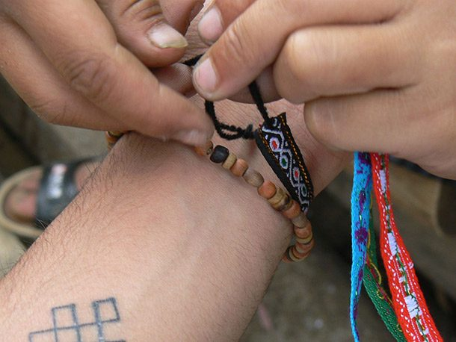

Source: http://en.rocketnews24.com

Japan schools only allow one good luck bracelet, anything greater than that is considered cheating. Apparently, there is such a thing as too much good luck.

5 An American school teacher restricts bathroom breaks to three times a week



Source: http://thestir.cafemom.com, Image: https://pixabay.com (public domain)

A New York school teacher limited her student’s bathroom breaks to three times a week, handing out coupons they can use. They get three minutes, and if they lose the coupons, then they’re going to have to hold it for quite a while.

## 6 Teachers in UK can't use red ink to grade papers



Source: http://time.com

Stating the color red is too negative, teachers in UK are banned from using it to grade their papers and must use a more calming color instead.

7 Winning is disfavoured by two out of three schools in the UK



Source:http://www.dailymail.co.uk,   
Image:https://commons.wikimedia.org (public domain)

Speaking of not hurting anyone’s feelings, a new study shows that two out of three schools in the UK are rewarding all students rather than handing out awards to the students who actually win at something.

**1.3 Relativism advocated by some Asian Cultures**

This universalist conception of “human rights” and “democracy” are generally adopted in western civilization has, however, regularly been called into question by developing countries in East Asia, especially those which have prospered economically in the absence of democratic governance and robust protection of individual rights. The argument is that “cultural diversity” does warrant a different approach to human rights and democracy in non-Western countries. For Western countries – typically economically, technologically, and militarily stronger – to impose their beliefs, values and institutions on the rest of the world is no more than cultural imperialism. This is closely associated to what is sometimes called the relativist argument or, simply, relativism. Singapore is a strong advocate for relativism.

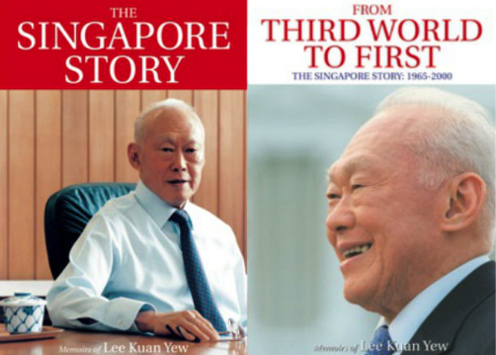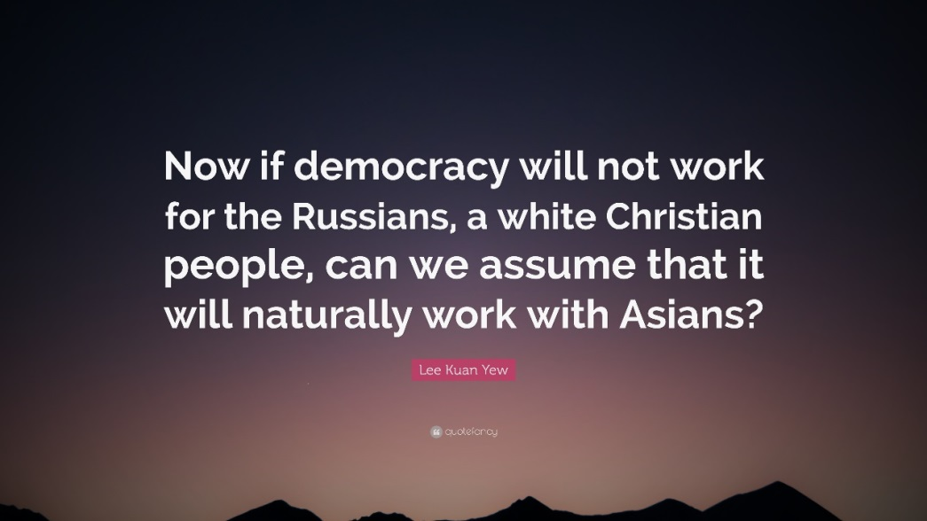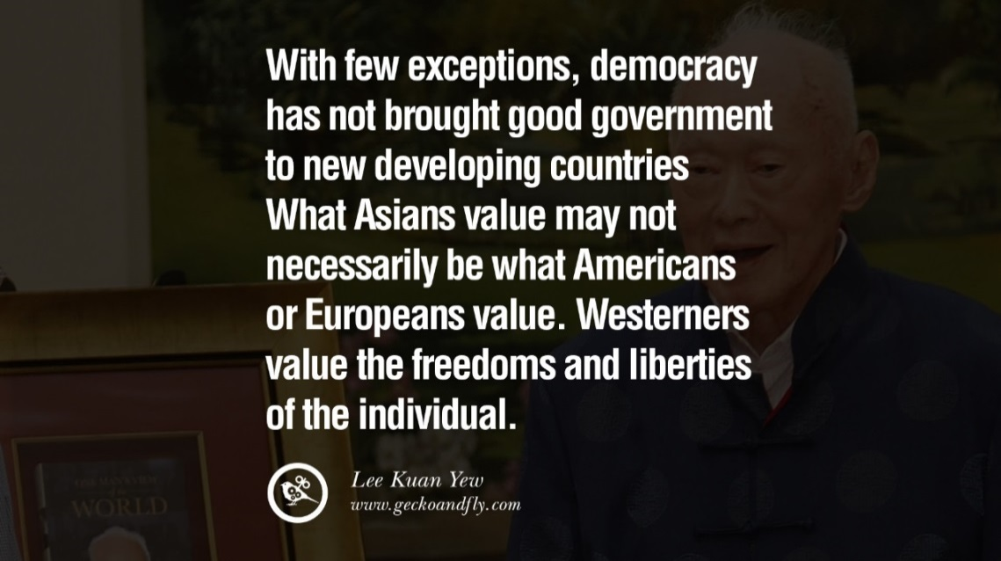

In short, relativists believe that there is no objective and universal truth about the definitions of justice and human rights. To them, ideas such as human rights are *relative* only to the society from which they are derived and are incapable of universality: what is considered important human rights in one society cannot, and ought not to, attract the same respect in another, culturally different society.

In 1947, the American Anthropological Association (AAA) wrote a "Statement on Human Rights" in response to the drafting of the UDHR. The statement asks, **"How can the proposed Declaration be applicable to all human beings, and not be a statement of rights conceived only in terms of the values prevalent in countries of Western Europe and America?"** The AAA questions whether any document can be universal, since individuals, it explains, cannot exist outside of their own culture; an individual could not have an identity separate from their cultural identity.   In this document, the AAA asks, in this case, whether the document can be universal if it reflects values of Western Europe and America? The UDHR is based on the belief that there is something basic and universal (across time, geography, language, and culture) that connects all human beings. Human Rights scholar Mary Ann Glendon explains:

[The idea of universality of human rights] is an idea that comes out of Western traditions, but even though that idea and the form and style can be said to be Western, it is impressive that in 1947 and 1948 representatives of Asian cultures, nine countries with predominantly Muslim populations, along with Latin America, Europe and the United States - all those representatives were able to sign on to those principles as universals.

Apart from the above, Saudi Arabia also abstained from the ratification vote on the Universal Declaration of Human Rights, claiming that it violated [Sharia law](https://en.wikipedia.org/wiki/Sharia) (Islamic law).

**1.4 The Real Meaning of “Universal”**

This leads us back to what “universality” really means. Contrary to the relativist thinking, universality of human rights is not a rigid concept, because it retains a measure of flexibility in its realisation in society. Local modifications to accommodate the reality of local circumstances are entirely compatible with universality; they only manifest a legitimate form of ethical de-centralisation, and may not be viewed as relativist. Indeed, it may be recalled that the 1993 Vienna Declaration itself recognises, having declared the universality of human rights, that "the significance of national and regional particularities and various historical, cultural and religious backgrounds must be borne in mind".

Culture, therefore can and should be respected to the extent that it can be reconciled with equality, dignity, human right and democracy, no less but no more. Human rights are not dependent on the fact that national governments may behave differently from each other so far as their politics, economic policy, and culture are concerned. Human rights are emphatically not a luxury reserved for those living in the comfort of developed civilisation. In other words, in determining whether a state can rely on its cultural peculiarity to restrict human rights which are based on inherent dignity of human beings, the following framework can be adopted:

1. The starting point is that all states are under a moral obligation to give effects to human rights which are based on inherent dignity of human beings;
2. Some academics believe that according to the Siracusa Principles**,** local modifications to human rights must be supported by convincing and specific justifications which explain why, on balance, such modifications are
   * legitimate
   * no more than necessary and;
   * the restriction means are rationally connected with the ends of restriction
3. Even when local modifications to human rights can be justified due to cultural reasons, the state should constantly review the situation and take positive steps to align its culture with universal human rights, e.g. through education.

<http://hrlibrary.umn.edu/instree/siracusaprinciples.html>

Apart from culture, “local laws” is another important factor to consider when exercising human rights. A learning activity on “Rights and the Rule of Law” will be discussed in chapter 5 of this package.



<http://www.basiclawcourtcase.gov.hk/tc/court-cases/case.html?id=30>

<http://www.hklii.hk/eng/hk/cases/hkcfa/1999/10.html>

In any event, it may be that the debate about relativism and universal human rights does not assume as much importance as it in the past did. Most of the world’s countries, including those in Africa, the Americas and Asia, are now willing parties to major international and regional human rights treaties. Furthermore, globalisation has largely transcended national and cultural boundaries once impenetrable. International trade, travel and migration and advancing electronic communication are amongst those factors which now enable countries to borrow freely and regularly from each other’s inventions and practices.

**Learning activity 4 The traditi**on **of *“Country A”***

In a hypothetical state “Country A”, it is a tradition that a man can get married only if he owns a flat of not less than 1000 square feet. As the property price in Country A surges, the young generation finds it more and more difficult to acquire a proper flat in order to get married. Some people start to question the rationale of the tradition and ignore it. In light of the trend that young people begin to ignore the tradition, the Country A’s government, which is dominated by conservative senior citizens, decides to enact a new law to enforce the tradition. The law provides that:

1. If a man gets married without owning a flat of not less than 1000 square feet, he will be liable to imprisonment for 2 years. The marriage will not be recognized under the law.
2. All men who do not own a flat of not less than 1000 square feet must take a prescribed drug which prevents them from having offspring. Anyone who fails to comply with this requirement will be liable to imprisonment for 7 years.

The new law has received wide support from the population of Country A. They welcome the new law as a measure to safeguard the core value and tradition of Country A. The Country A’s government also states that the purpose of the new law is to make sure that only men who are capable of raising a family should be allowed to form one. This helps to ensure the next generation of Country A would not live in poverty and would have access to high quality training from the family. Moreover, it incentivizes men of Country A to work hard and strive for the best. All these can boost up the competitiveness of Country A and are in the interest of the people of Country A collectively.

For those who oppose the new law, they argue that the new law infringes their human rights such as their right to marriage, their right to form a family, and their right to be free from interference with their bodies. Moreover, they argue that the new law constitutes a discrimination based on wealth and social status.

****You are a journalist working for an oversea news agency. What would you make use of 400 words and some pictures to introduce and evaluate the above to readers of the global community?

**Learning Activity 5 Choices of human rights**

Student will first receive cards representing European human rights (In virtue of simplicity, teacher may choose 8-10 human rights instead of 16):

|  |  |  |  |
| --- | --- | --- | --- |
| Right to life | Right to a fair trial | Right to express your views and opinions | Right to enjoy your belongings |
| Right not to be tortured or treated in a way which is cruel or intimidating | Right not to be punished for something if your action wasn’t against the law when you did it | Right to get together with people in a peaceful way and join a trade union | Right to an education |
| Right not to be required to do forced labour and not to be treated as a slave | Right to respect for private and family life, your home, letters, emails and phone calls | Right to marry and have a family | Right to vote in elections once you reach the voting age |
| Right to liberty (freedom) and security (protection) | Right to have your own thoughts, beliefs and religion | Right not to be treated unfairly in the enjoyment of your rights because of your age, race, religion, sex, disability or any other status | Right not to be sentenced to death for any crime |

Source: European Convention on Human Rights Cards (Easy to read version)

After letting student read and understand these rights, teacher may provide a scenario (a make up story with elements of change of government, famine, economic crisis, social unrests…) and ask student to surrender one of the cards, representing giving up the respective right. After collecting the cards, teacher may ask student to explain why they make such a choice (i.e. why they think that right is less important).

Continue with the collection of cards until student find difficult to give up, teacher may ask student to explain why they feel difficult to make any further concession. Teacher may then discuss with the class, concluding with the importance of all human rights.



**Simplified Version of Articles of the   
UDHR**

1 Everyone is free and we should all be treated in the same way.

2 Everyone is equal despite differences in skin colour, gender, religion, language, for example.

3 Everyone has the right to life and to live infreedom and safety.

4 No one has the right to treat you as a slave, nor should you make anyone your slave.

5 No one has the right to torture you or subject you to cruel and degrading treatment.

6 Everyone has the right to be treated equally by the law.

7 The law is the same for everyone; it should be applied in the same way to all.

8 Everyone has the right to ask for legal help when their rights are not respected.

9 No one has the right to imprison you unjustly or expel you from your own country.

10 Everyone has the right to a fair and public trial.

11 Everyone should be considered innocent until guilt is proved.

12 No one can enter your home, open your letters, or bother you or your family without a good reason.

13 Everyone has the right to travel where they wish.

14 Everyone has the right to go to another country and ask for protection if they are being persecuted or are in danger of being persecuted.

15 Everyone has the right to belong to a country. No one has the right to prevent you from belonging toanother country if you wish to.

16 Everyone has the right to marry and have a family.

17 Everyone has the right to own property and possessions.

18 Everyone has the right to practise and observe all aspects of their own religion and change their religion if they want to.

19 Everyone has the right to say what they think and to give and receive information.

20 Everyone has the right to take part in

meetings and to join associations in a peaceful way.

21 Everyone has the right to help choose and take part in the government of their country.

22 Everyone has the right to social security and to opportunities to develop their skills.

23 Everyone has the right to work for a fair wage in a safe environment and to join a trade union.

24 Everyone has the right to rest and leisure.

25 Everyone has the right to an adequate standard of living and medical help if they are ill.

26 Everyone has the right to an education.

27 Everyone has the right to participate in their community’s cultural life.

28 Everyone is entitled to a social and

international ‘order’ that is necessary for all these rights to be made real.

29 Everyone must respect the rights of others, the community and public property.

30 No one has the right to take away any of the rights in this declaration.

<http://www.un.org/en/udhrbook/>



Further Readings

Paolo G Carozza, 'Human Dignity' in Dinah Shelton (ed), The Oxford Handbook of International Human Rights Law (Oxford: OUP 2013);

Jack Donnelly, Universal Human Rights in Theory and Practice (3rd edn, New York: Cornell University Press 2013)

Nickel, James, “Human Rights”, The Stanford Encyclopedia of Philosophy (Spring 2017 Edition), Edward N. Zalta (ed.), URL = <https://plato.stanford.edu/archives/spr2017/entries/rights-human/>.